Terraform – 05
1). Watch the Terraform-05 video.
2). Execute the script shown in the video.
Remote State + State Locking
We'll use a separate project:
D:\Terraform\Terraform-remote-state
Step 1 — Create the folder
In Git Bash:
mkdir -p /d/Terraform/Terraform-remote-state
cd /d/Terraform/Terraform-remote-state
Open this folder in VS Code.
Your project:
Terraform-remote-state/
└── main.tf

Step 2 — Create main.tf
Initially, do not add the backend configuration.
Create:
main.tf
Put this in it:
provider "aws" {
region = "us-east-1"
}

resource "aws_s3_bucket" "s3_bucket" {
bucket = "s3backend-800380167135-2026"
}

resource "aws_dynamodb_table" "dynamodb_terraform_state_lock" {
name = "terraform-state-lock-dynamo"
billing_mode = "PAY_PER_REQUEST"
hash_key = "LockID"

attribute {
name = "LockID"
type = "S"
}
}
The PDF shows the S3 bucket named s3backend and the DynamoDB table named terraform-state-lock-dynamo; its example DynamoDB definition uses LockID as the hash key.
Why I used PAY_PER_REQUEST
The PDF's original example uses:
read_capacity = 20
write_capacity = 20
but for your current Terraform/AWS setup, PAY_PER_REQUEST is simpler and avoids provisioning capacity unnecessarily.

Step 3 — Check AWS credentials
Run:
aws sts get-caller-identity
Make sure you're using the AWS account you intend to use.
Then:
aws configure list
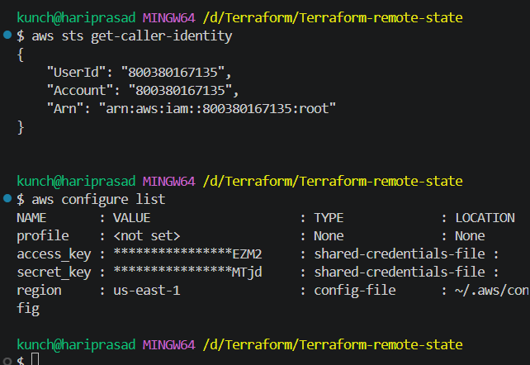

Step 4 — Initialize Terraform
Run:
terraform init
Expected:
Terraform has been successfully initialized!
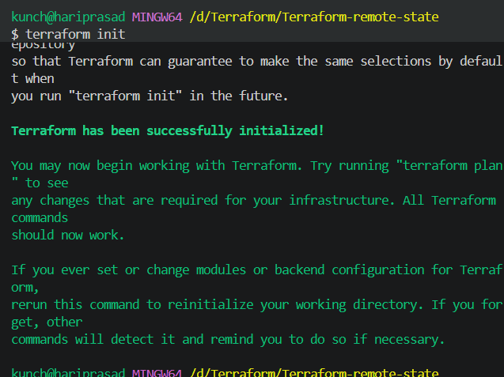

Step 5 — Format and validate
terraform fmt
Then:
terraform validate
Expected:
Success! The configuration is valid.
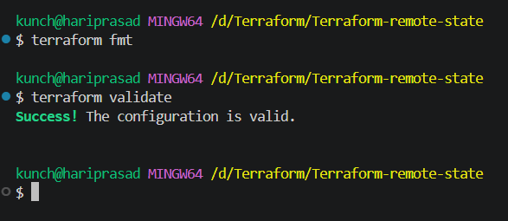

Step 6 — Plan
Run:
terraform plan
You should see:
Plan: 2 to add, 0 to change, 0 to destroy.
The resources are:
aws_s3_bucket.s3_bucket
aws_dynamodb_table.dynamodb_terraform_state_lock
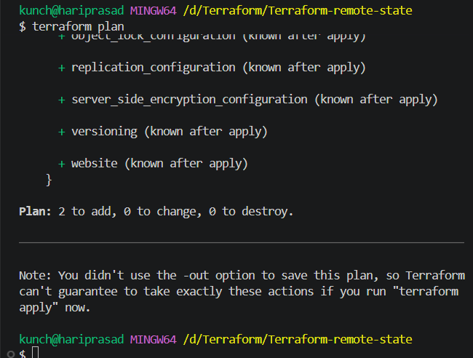

Step 7 — Apply
Run:
terraform apply
When asked:
Do you want to perform these actions?
enter:
yes
You should get:
Apply complete! Resources: 2 added, 0 changed, 0 destroyed.
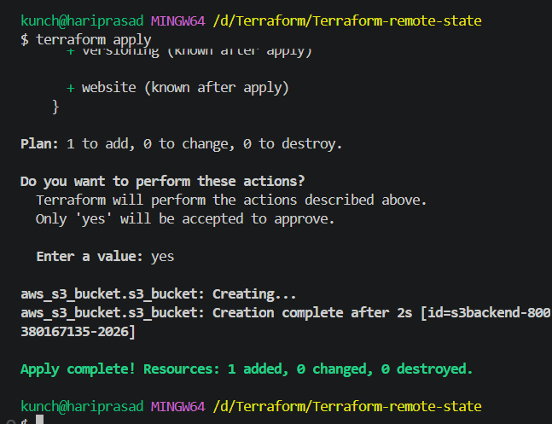

Step 8 — Verify S3
Run:
aws s3 ls
You should see:
s3backend-800380167135-2026
You can also run:
aws s3api head-bucket --bucket s3backend-800380167135-2026
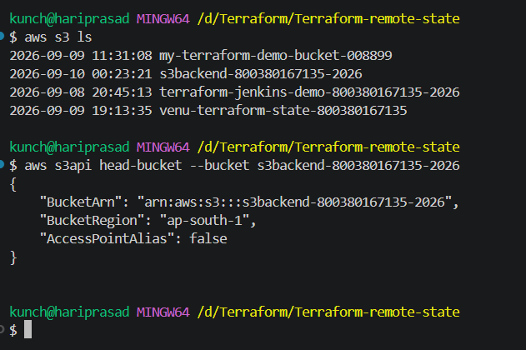

Step 9 — Verify DynamoDB
Run:
aws dynamodb describe-table \
--table-name terraform-state-lock-dynamo \
--region ap-south-1 \
--query "Table.[TableName,TableStatus]" \
--output table
Expected:
---------------------------------
| DescribeTable |
+-------------------------------+
| terraform-state-lock-dynamo |
| ACTIVE |
+-------------------------------+
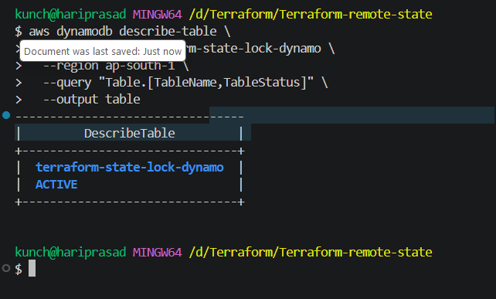

Step 10 — Now configure S3 as the backend
This is the important part shown on page 3 of your PDF. The PDF configures:
- bucket = s3backend-800380167135-2026
- DynamoDB table = terraform-state-lock-dynamo
- key = terraform.tfstate
- region = ap-south-1
Add this at the top of main.tf:
terraform {
backend "s3" {
bucket = "s3backend-800380167135-2026"
dynamodb_table = "terraform-state-lock-dynamo"
key = "terraform.tfstate"
region = "us-east-1"
}
}
Your complete main.tf becomes:
terraform {
backend "s3" {
bucket = "s3backend-800380167135-2026"
dynamodb_table = "terraform-state-lock-dynamo"
key = "terraform.tfstate"
region = "ap-south-1"
}
}

provider "aws" {
region = " ap-south-1"
}

resource "aws_s3_bucket" "s3_bucket" {
bucket = "s3backend-800380167135-2026"
}

resource "aws_dynamodb_table" "dynamodb_terraform_state_lock" {
name = "terraform-state-lock-dynamo"
billing_mode = "PAY_PER_REQUEST"
hash_key = "LockID"

attribute {
name = "LockID"
type = "S"
}
}
Save:
Ctrl + S
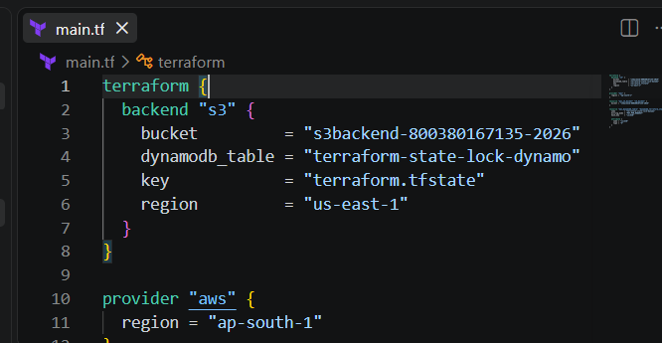

Step 11 — Reinitialize and migrate state
Now run:
terraform init
Terraform should detect that the backend has changed.
You may see:
Do you want to copy existing state to the new backend?
Answer:
Yes
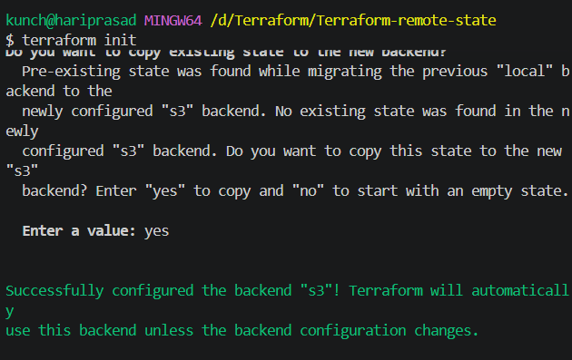
This describes this migration as:
Local terraform.tfstate
↓
s3backend-800380167135-2026
↓
terraform.tfstate
This is the core remote-state portion of the task.

Step 12 — Verify the state in S3
Run:
aws s3 ls s3://s3backend-800380167135-2026/
You should now see:
terraform.tfstate
🎉 Remote state is working.
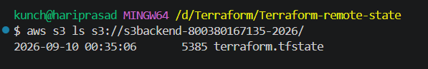

Step 13 — Verify Terraform state
Run:
terraform state list
You should see:
aws_dynamodb_table.dynamodb_terraform_state_lock
aws_s3_bucket.s3_bucket
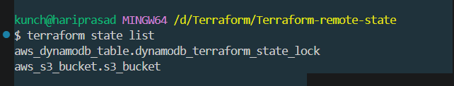

Step 14 — Test the backend
Run:
terraform plan
Expected:
No changes. Your infrastructure matches the configuration.
The final workflow explains that S3 stores the Terraform state while DynamoDB provides the state lock.
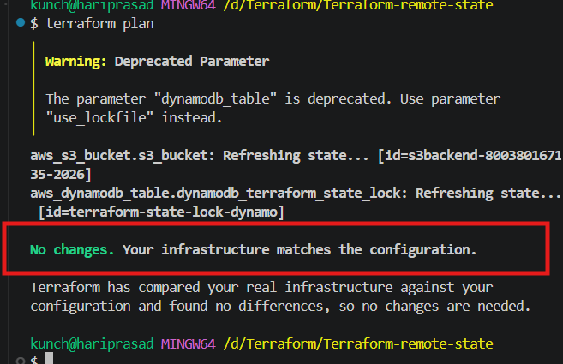
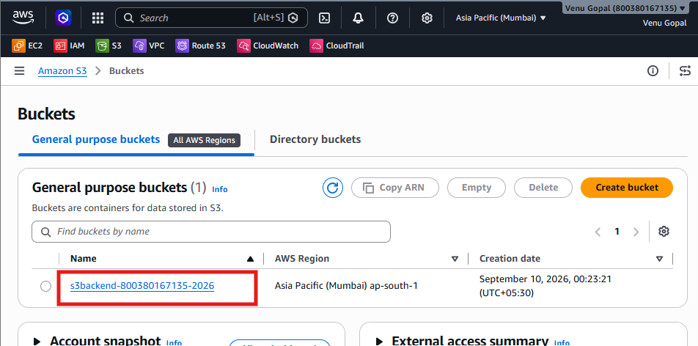
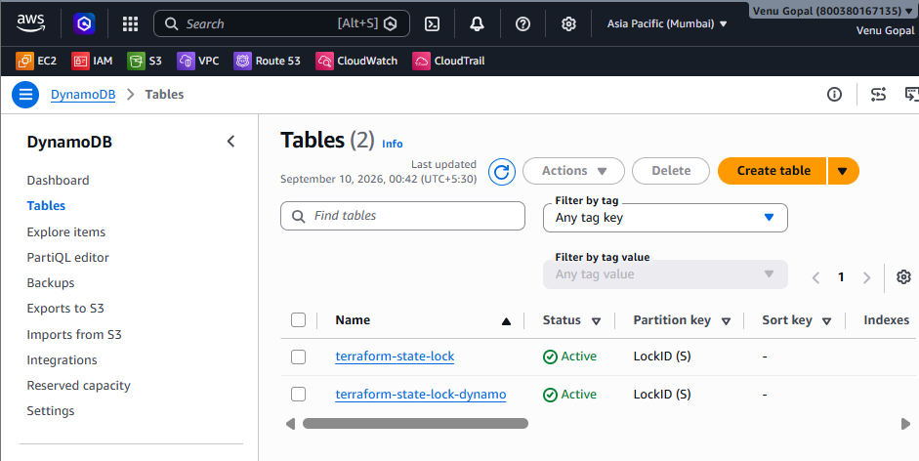
3). Create one EC2 instance with httpd installed using a Terraform script.
1. Open your Task 3 folder in VS Code
Open:
D:\Terraform\Terraform-ec2-httpd
Your VS Code Explorer should look like:
Terraform-ec2-httpd
We will create these files:
Terraform-ec2-httpd
│
├── main.tf
├── outputs.tf
└── backend.tf

2. Create main.tf
In VS Code Explorer:
Right-click Terraform-ec2-httpd → New File → main.tf
Paste this:
terraform {
required_providers {
aws = {
source = "hashicorp/aws"
version = "~> 6.0"
}
}

required_version = ">= 1.0"
}

provider "aws" {
region = "ap-south-1"
}

# Security Group
resource "aws_security_group" "apache_sg" {
name = "terraform-apache-sg"
description = "Allow HTTP traffic"

ingress {
description = "HTTP"
from_port = 80
to_port = 80
protocol = "tcp"
cidr_blocks = ["0.0.0.0/0"]
}

egress {
from_port = 0
to_port = 0
protocol = "-1"
cidr_blocks = ["0.0.0.0/0"]
}

tags = {
Name = "Terraform-Apache-SG"
}
}

# EC2 Instance
resource "aws_instance" "apache_server" {
ami = "ami-0f918f7e67a3323f0"
instance_type = "t2.micro"

vpc_security_group_ids = [
aws_security_group.apache_sg.id
]

user_data = <<-EOF
#!/bin/bash

dnf update -y

dnf install -y httpd

systemctl enable httpd

systemctl start httpd

echo "<h1>Apache HTTPD Server - Created Using Terraform</h1>" > /var/www/html/index.html
EOF

tags = {
Name = "Terraform-Apache-Server"
}
}
Press:
Ctrl + S

3. Create outputs.tf
Right-click the folder → New File → type:
outputs.tf
Paste:
output "apache_server_public_ip" {
description = "Public IP address of Apache server"
value = aws_instance.apache_server.public_ip
}

output "apache_server_url" {
description = "Apache HTTPD URL"
value = "http://${aws_instance.apache_server.public_ip}"
}
Save:
Ctrl + S

4. Open VS Code Terminal
In VS Code:
Terminal → New Terminal
You should see something like:
PS D:\Terraform\Terraform-ec2-httpd>
Make sure you are in the correct folder.
Run:
terraform init
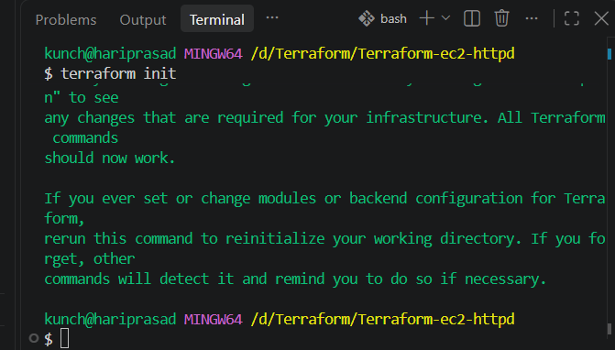

5. Validate
Run:
terraform validate
Expected:
Success! The configuration is valid.
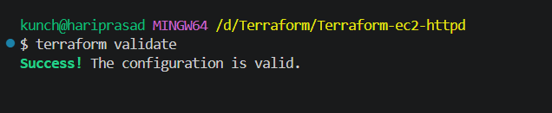

6. Format
Run:
terraform fmt

7. Check the plan
Run:
terraform plan
You should see:
Plan: 2 to add, 0 to change, 0 to destroy.
Why 2?
Because Terraform creates:
1 Security Group
+
1 EC2 Instance
=
2 resources
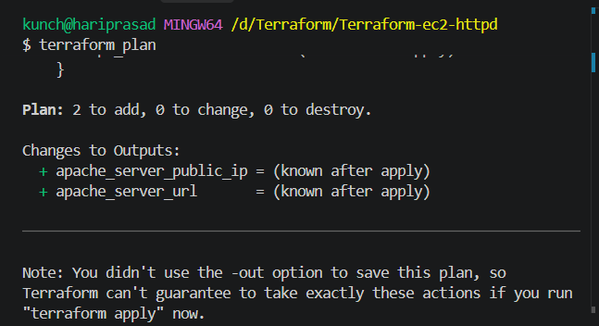

8. Create the EC2
Run:
terraform apply
Terraform will ask:
Do you want to perform these actions?
Enter:
yes
Wait for completion.
You should see:
Apply complete! Resources: 2 added, 0 changed, 0 destroyed.
And Terraform should display:
apache_server_public_ip = "xxx.xxx.xxx.xxx"

apache_server_url = http://xxx.xxx.xxx.xxx
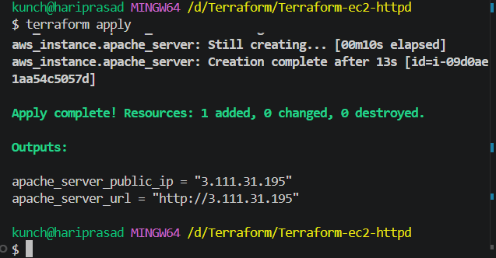

One important problem
At this point, Apache is installed, but you may not be able to access it from your browser.
Why?
Because the EC2 security group needs to allow:
HTTP
Port 80
So let's add a security group to Terraform instead of manually creating one.
Step 9 — Update main.tf
Replace your current main.tf with this:
terraform {
required_providers {
aws = {
source = "hashicorp/aws"
version = "~> 6.0"
}
}

required_version = ">= 1.0"
}

provider "aws" {
region = "ap-south-1"
}

resource "aws_security_group" "apache_sg" {
name = "terraform-apache-sg"
description = "Allow HTTP and SSH traffic"

ingress {
description = "HTTP"
from_port = 80
to_port = 80
protocol = "tcp"
cidr_blocks = ["0.0.0.0/0"]
}

ingress {
description = "SSH"
from_port = 22
to_port = 22
protocol = "tcp"
cidr_blocks = ["0.0.0.0/0"]
}

egress {
from_port = 0
to_port = 0
protocol = "-1"
cidr_blocks = ["0.0.0.0/0"]
}

tags = {
Name = "Terraform-Apache-SG"
}
}

resource "aws_instance" "apache_server" {
ami = "ami-0f918f7e67a3323f0"
instance_type = "t2.micro"

vpc_security_group_ids = [
aws_security_group.apache_sg.id
]

user_data = <<-EOF
#!/bin/bash
dnf update -y
dnf install -y httpd
systemctl enable httpd
systemctl start httpd

echo "<h1>Apache HTTPD Server - Terraform</h1>" > /var/www/html/index.html
EOF

tags = {
Name = "Terraform-Apache-Server"
}
}
Then run:
terraform fmt
terraform validate
terraform plan
terraform apply
Type:
Yes
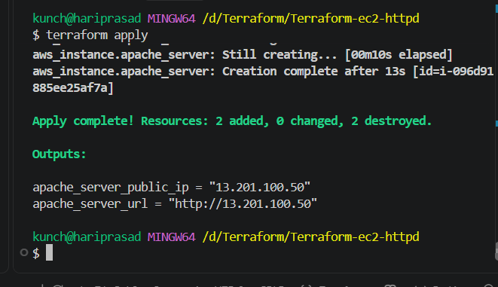

Step 10 — Get the EC2 public IP
Run:
terraform state show aws_instance.apache_server
Look for:
public_ip = "..."
For example:
public_ip = "13.233.xxx.xxx"
apache_server_public_ip = "13.201.100.50"
apache_server_url = "http://13.201.100.50"
Step 11 — Test Apache
Open your browser and enter:
http://YOUR_PUBLIC_IP
For example:
http://13.233.xxx.xxx
You should see:
Apache HTTPD Server - Terraform
🎉 Task 3 requirement is now completed.
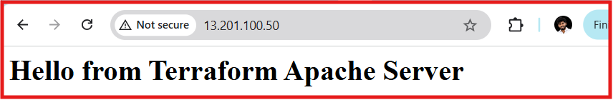

4). Set up S3 as backend for task 3.
Step 1: Create an S3 bucket
From AWS CLI:
aws s3api create-bucket \
--bucket venu-terraform-state-800380167135 \
--region ap-south-1 \
--create-bucket-configuration LocationConstraint=ap-south-1
Verify:
aws s3 ls
You should see:
venu-terraform-state-800380167135
Bucket names must be globally unique. If this name is already taken, change it.
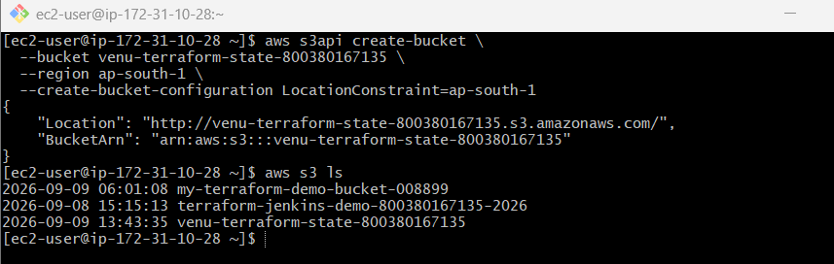

Step 2: Enable versioning
Terraform state is very important, so enable versioning.
aws s3api put-bucket-versioning \
--bucket venu-terraform-state-800380167135 \
--versioning-configuration Status=Enabled
Verify:
aws s3api get-bucket-versioning \
--bucket venu-terraform-state-800380167135
Expected:
{
"Status": "Enabled"
}
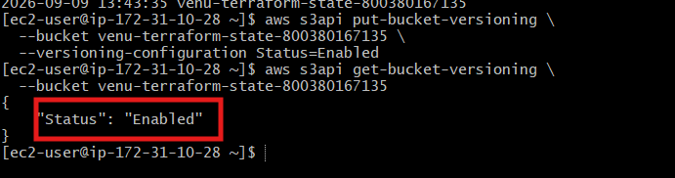

Set up S3 as Terraform Backend
Step 1 — Create backend.tf
In VS Code:
Right-click your project folder → New File → backend.tf
Put this inside:
terraform {
backend "s3" {
bucket = "venu-terraform-state-800380167135"
key = "terraform-ec2-httpd/terraform.tfstate"
region = "ap-south-1"
}
}
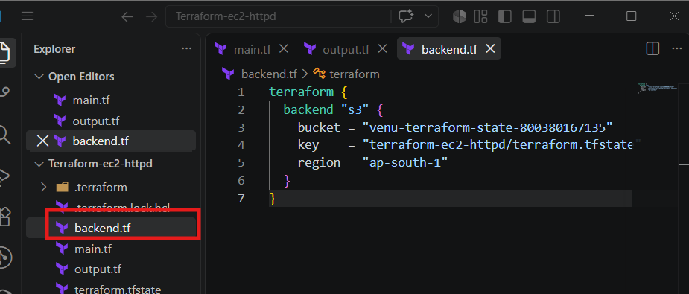
Step 2 — Make sure the S3 bucket exists
You previously created:
venu-terraform-state-800380167135
Verify:
aws s3 ls
You should see:
venu-terraform-state-800380167135
You can also check:
aws s3 ls s3://venu-terraform-state-800380167135
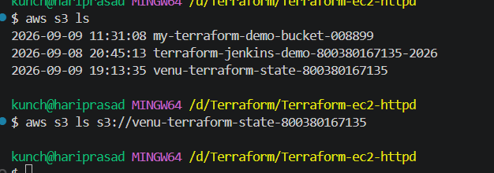
Step 3 — Initialize the backend
Because you're changing from local state to S3 state, run:
terraform init -migrate-state
Terraform may ask:
Do you want to copy existing state to the new backend?
Enter:
yes
You should eventually see:
Successfully configured the backend "s3"!
Terraform has been successfully initialized!
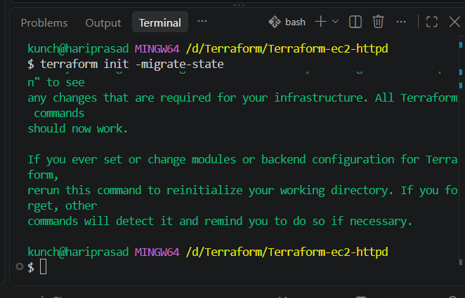
Step 4 — Verify the state is in S3
Run:
aws s3 ls s3://venu-terraform-state-800380167135/terraform-ec2-httpd/
You should see:
terraform.tfstate
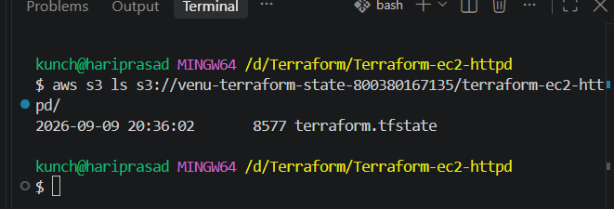
Step 5 — Verify Terraform
Run:
terraform plan
Ideally:
No changes. Your infrastructure matches the configuration.
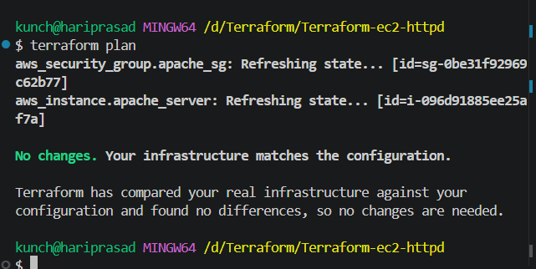
Important
Don't delete your local terraform.tfstate manually before terraform init -migrate-state.
Terraform will migrate the existing state to S3.
5). Set up DynamoDB locking for task 3.
Step 1: Create a DynamoDB table
In your VS Code terminal, run:
aws dynamodb create-table \
--table-name terraform-state-lock \
--attribute-definitions AttributeName=LockID,AttributeType=S \
--key-schema AttributeName=LockID,KeyType=HASH \
--billing-mode PAY_PER_REQUEST \
--region ap-south-1
You should get a response showing:
TableName: terraform-state-lock
TableStatus: CREATING
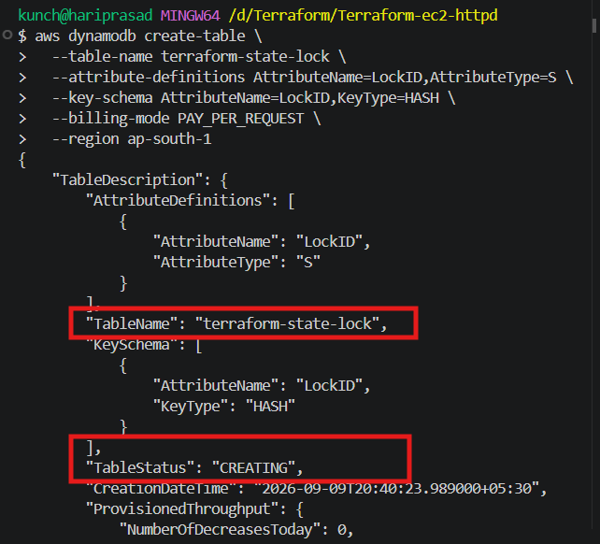
Step 2: Check the table
Run:
aws dynamodb describe-table \
--table-name terraform-state-lock \
--region ap-south-1 \
--query "Table.[TableName,TableStatus]" \
--output table
Expected:
-------------------------
| DescribeTable |
+----------------------+
| terraform-state-lock |
| ACTIVE |
+----------------------+
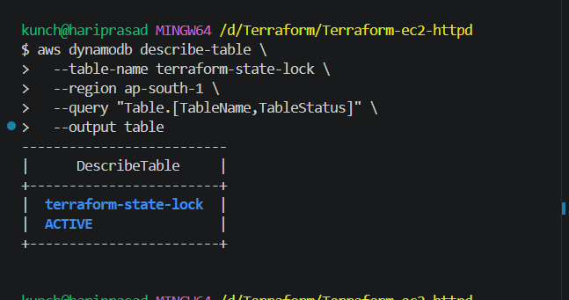
Step 3: Update backend.tf
Your current backend.tf probably looks like:
terraform {
backend "s3" {
bucket = "venu-terraform-state-800380167135"
key = "terraform-ec2-httpd/terraform.tfstate"
region = "ap-south-1"
}
}
Change it to:
terraform {
backend "s3" {
bucket = "venu-terraform-state-800380167135"
key = "terraform-ec2-httpd/terraform.tfstate"
region = "ap-south-1"
dynamodb_table = "terraform-state-lock"
}
}
Save with:
Ctrl + S
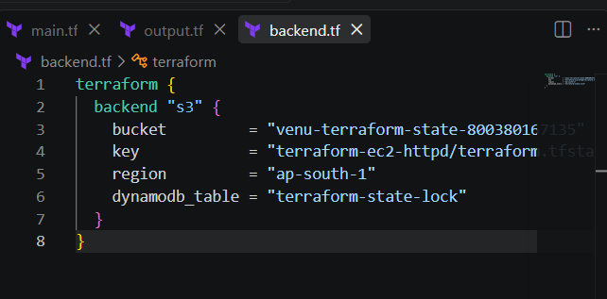
Step 4: Reinitialize Terraform
Run:
terraform init -reconfigure
You should see something similar to:
Initializing the backend...

Successfully configured the backend "s3"!
Terraform has been successfully initialized!
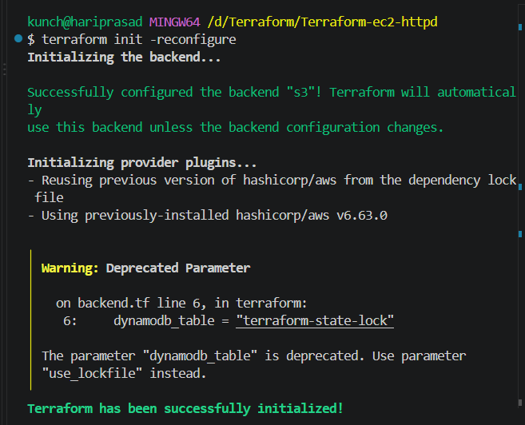
Step 5: Verify
Run:
terraform plan
You should ideally get:
No changes. Your infrastructure matches the configuration.
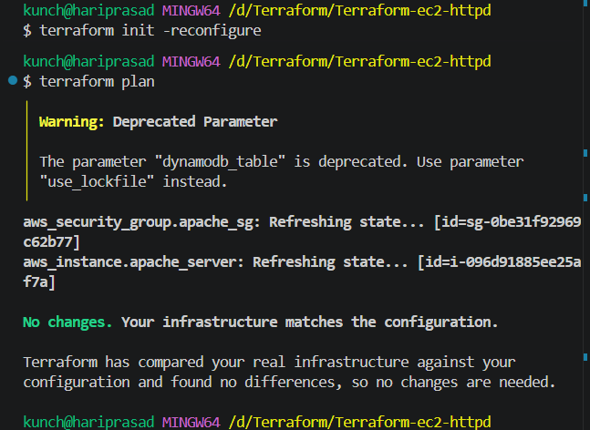
Step 6: Verify your S3 state
Run:
aws s3 ls s3://venu-terraform-state-800380167135/terraform-ec2-httpd/
You should see:
terraform.tfstate
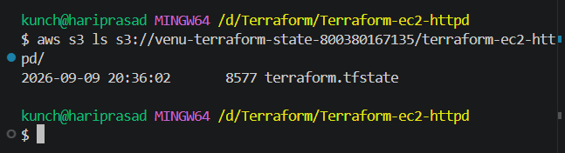
Step 7: Verify DynamoDB
Run:
aws dynamodb describe-table \
--table-name terraform-state-lock \
--region ap-south-1 \
--query "Table.TableName"
Expected:
"terraform-state-lock"
